How to share your Google Business Profile with NADA Analytics.

- Open a Google browser (Chrome)

- Make sure you are logged in under the profile that manages your dealership profile.

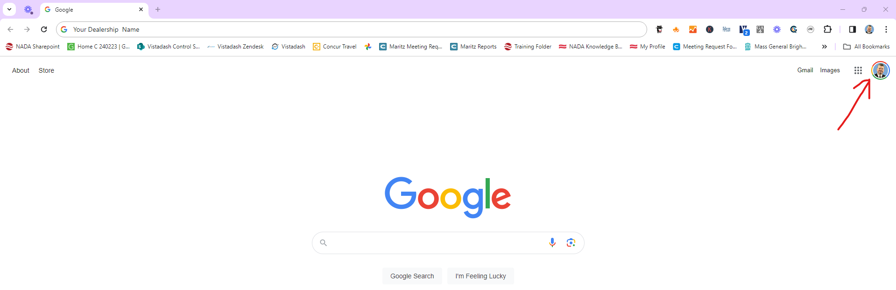

- Search your Business Name
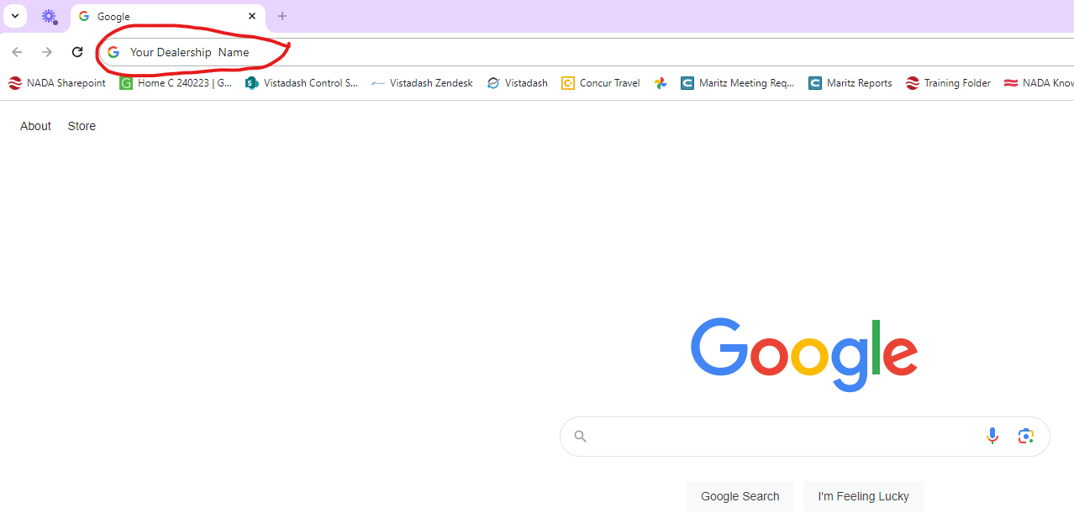

- Your Business profile edit features will load

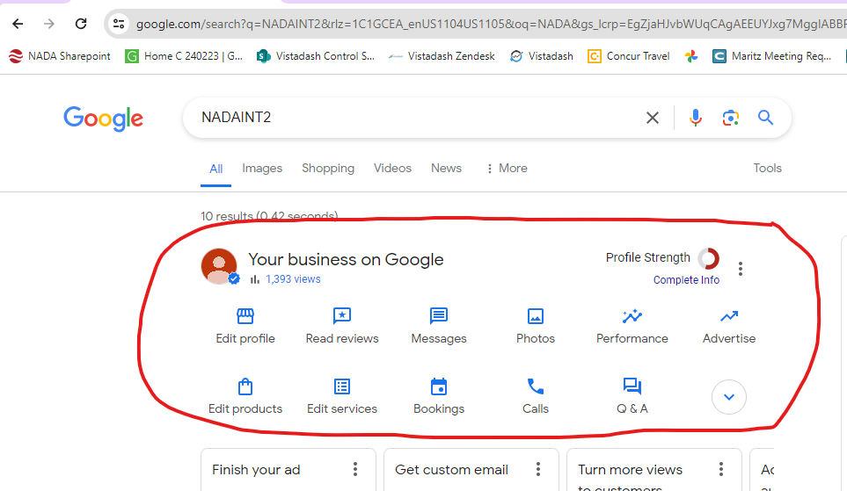

- Click on the 3 dots on the right of them

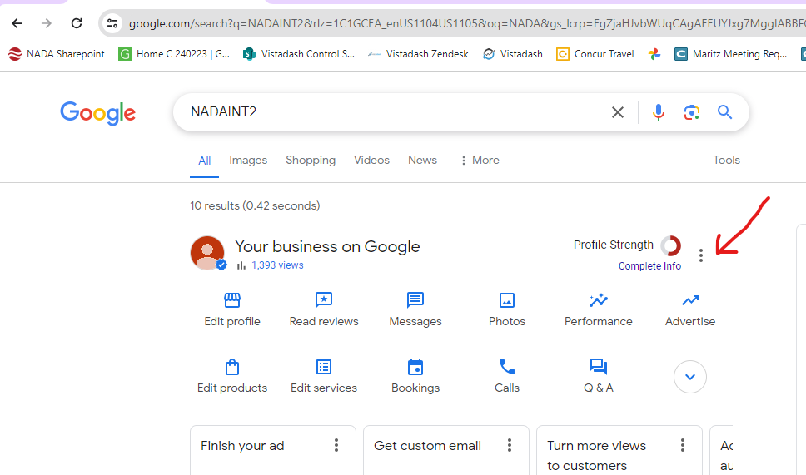

- Click on Business Profile settings

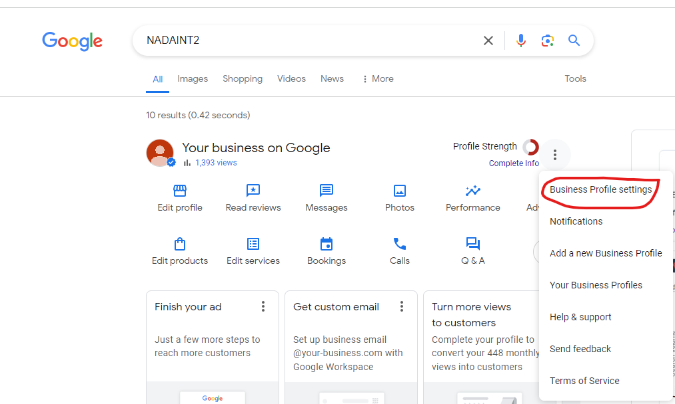

- Select People & Access

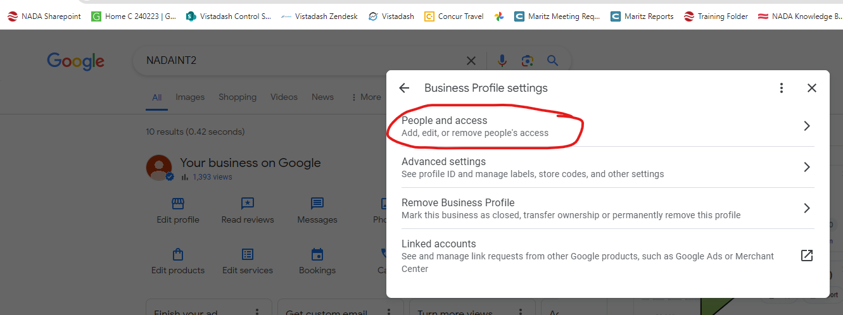

- When users pop up, select “Add”

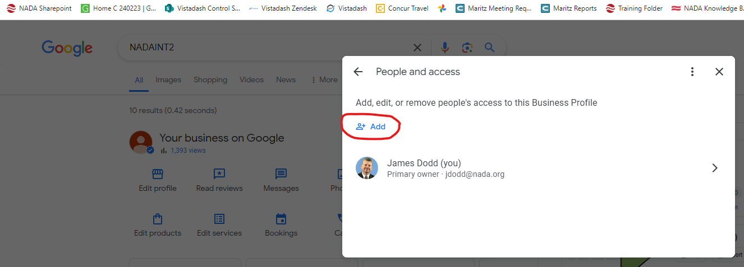
- Enter the Assigned email address you received from your consultant

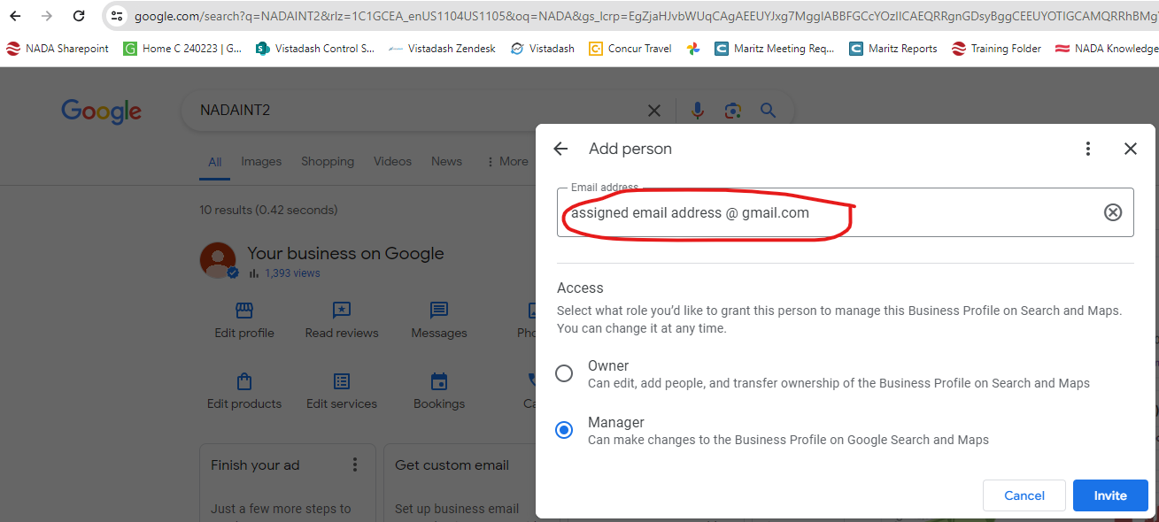

- Then click on “Invite”

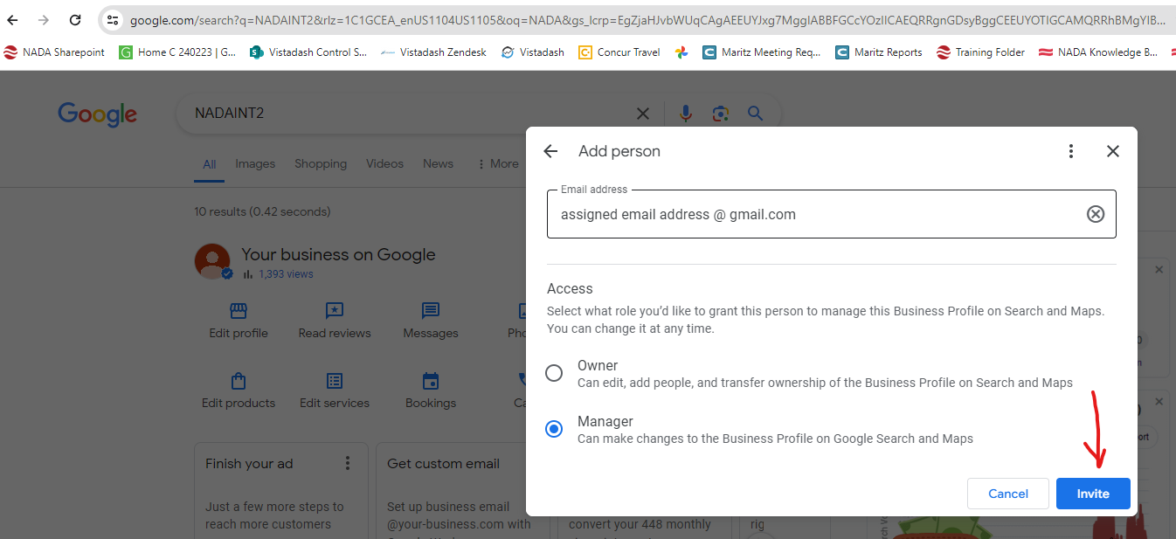

The request will go to the team at Vistadash and bee approved.
Once approved, data will begin transferring and become visible in the following month composite.

Click here to see a video

